MISSOURI SOLID WASTE MANAGEMENT DISTRICT PLANNERS AND CONTACT INFORMATION
REGION A – Northwest Missouri SWMD Cassie Hasekamp
114 W. Third St.
Maryville, MO 64468
660-582-5121 cassie@nwmocrgog.org https://nwmorcog.org/ programs/ solid-waste/
REGION B – North Missouri SWMD Ann Hamilton
1104 Main St.
Trenton, MO 64683
660-359-5086, ext. 20 ann@ghrpc.org http://www.ghrpc.org/Programs/ solidwaste.htm
REGION C – Northeast Missouri SWMD Lucinda Clubb
121 S. Cecil St.
Memphis, MO 63555
660-465-7281
lucindaclubb@nemorpc.org http://www.nemorpc.org/solid- waste-management-district/
REGION D – District D Recycling SWMD Brenda Kennedy
114 Main St.
P.O. Box 139
Clarksdale, MO 64430
816-393-5250 regiond@stjoewireless.com http://www.regiondrecycling.com/
REGION E – Mid American Regional Council SWMD Lisa McDaniel
600 Broadway, Ste. 600 Kansas City, MO 64105 816-474-4240 816-421-7758 lmcdaniel@MARC.org https://www.marc.org/ Environment/Solid-Waste.html

REGION F – West Central SMWD Derrick Standley
27 Point Hickory Ct.
Lake Ozark, MO 65049
314-420-3058 Dstandleyusa@outlook.com http://moswmd-f.com/
REGION G – Mark Twain SWMD
Devyn Campbell
42494 Delaware Lane
Perry, MO 63462
573-565-2203 http://moswmd-f.com/ campbellcog@outlook.com
REGION H – Mid-Missouri SWMD Leland Rehard
P.O. Box 6015
701 E. Broadway
Columbia, MO 65205
573-874-7574
573-289-8255 cell Lelande.rehard@como.gov https://www.mmswmd.org/
REGION I – East Central SWMD Chad Eggen
P.O. Box 429
111 Steinhagen
Warrenton, MO 63383
636-456-3473 ceggen@boonslick.org http://boonslick.org/recycling-center/
REGION J – Quad-Lakes SWMD
Michelle Slater
221 N. Second St.
Clinton, MO 64735
660-885-3393 mslater@kaysinger.com http://kaysinger.com/quad_ lakes.php/

REGION K – Ozark Rivers SWMD Tammy Snodgrass
#4 Industrial Drive
St. James, MO 65559
573-265-2993 tsnodgrass@meramecregion.org http://ozarkrivers.org/
REGION L – St. Louis-Jefferson SWMD David Berger
7525 Sussex Ave.
St. Louis, MO 63143
314-645-6753 David@swmd.net https://www.swmd.net/

REGION M – Region M SWMD
Patty Overman
800 E. Pennell St.
Carl Junction, MO 64834 417-649-6400 pvoerman@hstcc.org https://www.hstcc.org/region-m-swmd

REGION N – Southwest Missouri SWMD Natalie Moseley
205 15th St.
P.O. Box 27
Monett, MO 65708
417-236-9012
swaste@mo-net.com https://dnr.mo.gov/env/swmp/ swmd/distn.htm

REGION O – Ozark Headwaters Recycling and Materials Mngt. District Angie Snyder
940 N. Boonville Ave., Room 303B
Springfield, MO 65802
417-868-4197 asnyder@greencountymo.org https://www.recycle417.com

REGION P – South Central SWMD Cody Dalton
P.O. Box 100
Pomona, MO 65789
417-256- 4226 cdalton@scocog.org https://www.scocog.org/
REGION Q – Ozark Foothills RPC Andrew Murphy
3019 Fair St.
Poplar Bluff, MO 63901
573-785-6402
andrew@ofrpc.org http://www.ofrpc.org
REGION R – Southeast MO RPC Rebecca Pecaut
1 West St. Joseph St.
Perryville, MO 63775
573-547-8357
rpecaut@semorpc.org http://semorpc.org/
REGION S – Bootheel RPC Kent Luke
105 E. North Main
Dexter, MO 63841
573-614-5178
kluke@bootrpc.com http://www.bootrpc.com/
REGION T – Lake of the Ozarks SWMD Ethan Shackelford
33924 Olathe Drive
Lebanon, MO 65536
417-426-5001 eshackelford@wcamerica.com http://lakeswmd.com/1/

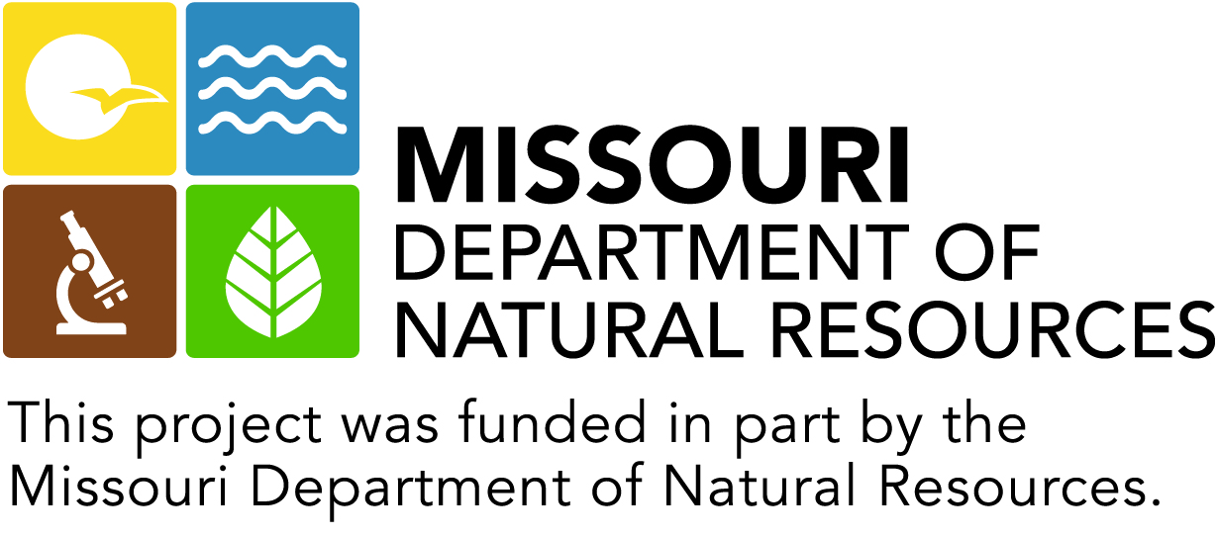
Missouri’s Materials Management Directory at https://recyclesearch.com/profile/mo-directory allows people to find local contractors, vendors, drop-off locations offering recycling, refurbishing and options for disposal. If you have a business or organization involved in materials or waste management in Missouri, the department encourages you to add your business and the services you provide to the directory.

